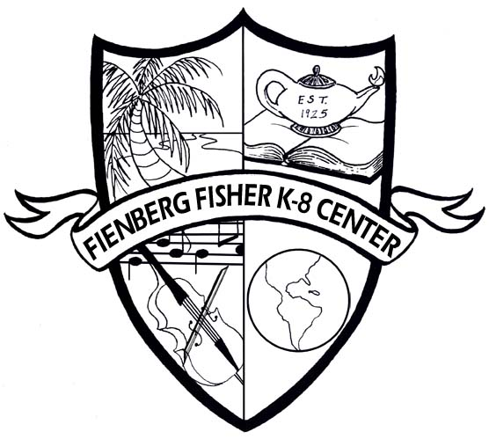
8th Grade Language Arts
Fienberg-Fisher K-8 Center
8th grade Summer 2013 Reading List

Incoming eighth graders must select two of the novels below assigned by the Reading/Language Arts Department. Students are also required to select and complete one of the projects for each of the novels chosen. Novel selections are determined by the grade level, IB program, and 8th grade teacher recommendations.

The Giver by Lois Lowry
Choose ONE of the following projects. This project is a REQUIRED assignment. Projects are due the first week of school.
Option #1: Select captivating quotations that you can use to persuade a prospective reader to choose The Giver. Create a book jacket and incorporate the quotations. See Directions below
Option #2: Many people are disappointed with the ending of the novel. Create your own ending for The Giver. The ending needs to be three pages typed or four pages written.
Option #3: Research another utopian-like community, such as the Shakers. Write a comparison between that community and the one presented in The Giver, in which you consider the rules of conduct within the community as well as its relationship with the outside world. Create a poster size Venn Diagram to show the comparisons between that community and the community in The Giver.

To Kill a Mockingbird by Harper Lee
Choose ONE of the following projects. This project is a REQUIRED assignment. Projects are due the first week of school.
Option #1: Write two articles for The Maycomb Gazette--one just after the trial of Tom Robinson and another after the death of Bob Ewell. Include a news article and illustrations with captions
Option #2: Scout and Jem have inherited a legacy of values from their father. Project either character into adulthood and write a two-page letter thanking Atticus for the specific lessons and examples you learned from him while growing up.
Option #3: Become Scout and create an annotated scrapbook of at least 5 pages. On each page, paste in something that reflects some aspect of Scout’s experience growing up.
Make sure that at least two items are written--for example a letter from Dill, a newspaper article, or a diary entry. Annotate each entry as Scout, explaining why she is saving this item.

A Separate Peace by John Knowles
Choose ONE of the following projects. This project is a REQUIRED assignment. Projects are due the first week of school.
Option #1: Design a poster to advertise your book. Be creative…use details…elaborate…use color! You can make it 3-D or movable.
Option #2: Choose one of the main characters of the story. Write a character diary, writing at least six journal entries as if you are one of the main characters in the story. Write down the events that happen during the story and reflect on how they affected the character and why. The journal entries need to be at least four paragraphs long.
Option #3: Draw a portrait of the main character of the story and write a summary to accompany your sketch.

Book Jacket Directions:
1. Look at a minimum of five examples of hardcover book jackets before beginning this project. (Go to a library or any bookstore)
2. Using construction paper of whatever color you wish, design a book jacket. Fold the paper like the picture below. Fold it like a real book jacket (see sketch below).
3. You may create your book jacket by using the computer, by hand or using a combination of both.
4. Design your book jacket so it includes the information generally found on a book jacket (see information below).
5. Be original! Be creative! Use color! Use your imagination! Have fun!

